**141 – 113 Extra Credit Project**

**Calvin Kuo**

**404931398**

**Introduction:**

The goal is to design a algorithm that allows a drone to fly up a certain height and record signals in order to determine the location of a signal emitting source.

**Strategy:**

I decided to solve the problem by flying my drone up to one height and recording the signal from the source. Then fly up to a different height and record the same signal from a different distance. The two heights I flew to were known on my coordinate system as (0,5) and (0,10) because I chose to fly the drone up to height 5m and 10m.

I then denoised the signals with a moving average filter. Then I found the average power of the signal at 5m and 10m separately. Using the power and distance equation given in the specifications, I could compute the location of the source.

Below (left) is the power equation were Pl is the average power of a signal at a certain height, Kl is 1, Pt is the average power of the source’s original signal, and dl is the distance. On the right is the distance equation representing the distance dl between a sensor of coordinate (xl,yl) to a source of coordinate (x,y).

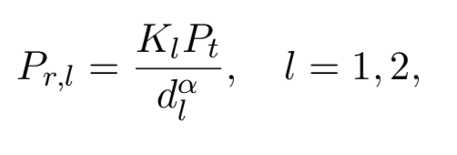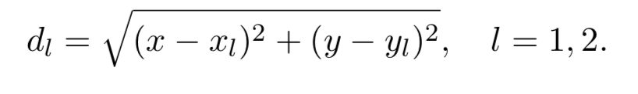

In order to fly my drone to the desired height, I used a combination of ramp functions with slope 1 and -1 in order to set the height equal to constant values (when two equal slopes cancel out) and move the drone up when the slope is positive.

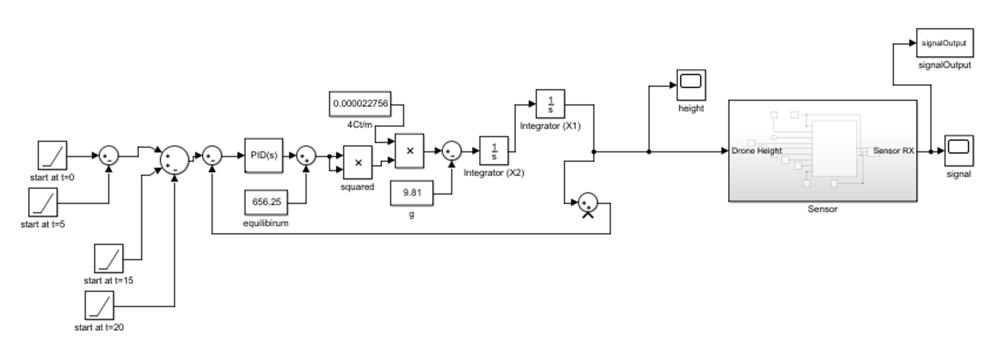

**Figure 1: Block Diagram of the drone flight system connected to the Sensor module. The output is a signal representing what the drone senses.**

The following figures show records of the process I went through in creating the algorithm to estimate the location of the source. First, I took a raw signal from Simulink. Then I denoised the signal in Matlab using a moving average filter. I then split the denoised signal into samples from 5m and 10m and calculated the average power at these two different heights.

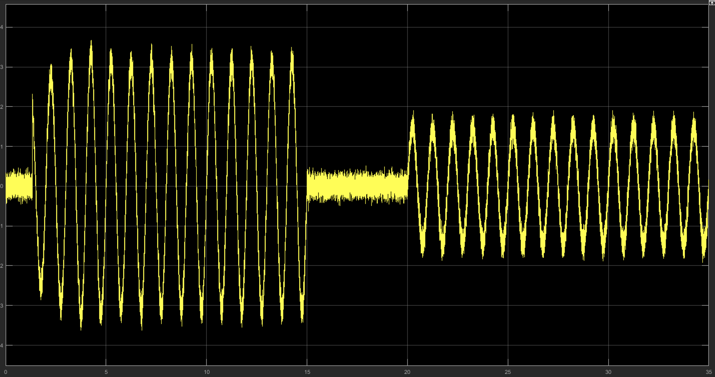

**Figure 2: Raw signal from Simulink.**

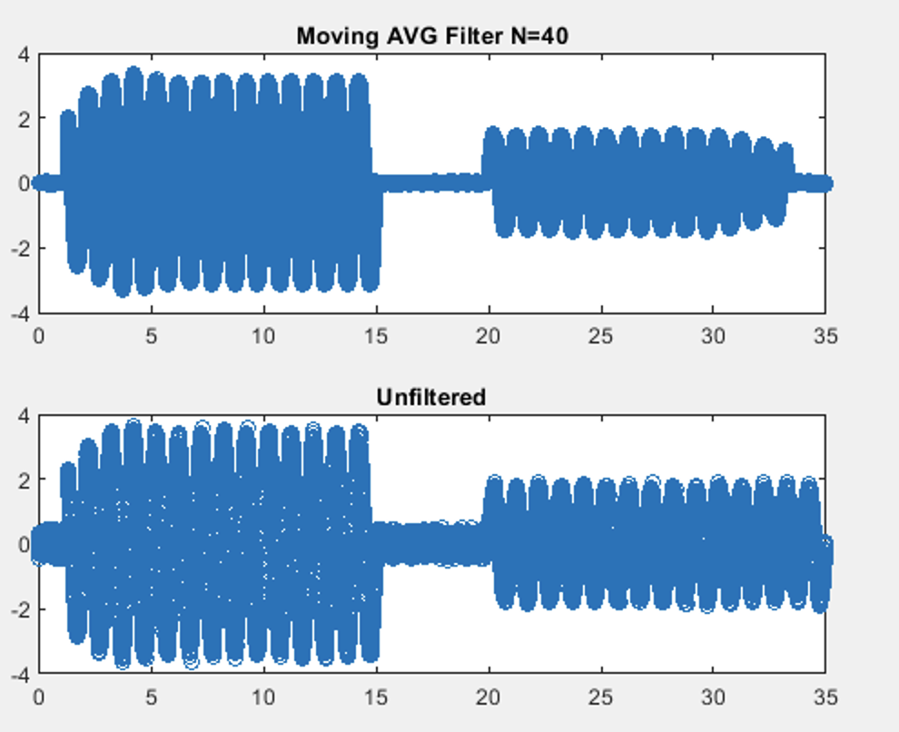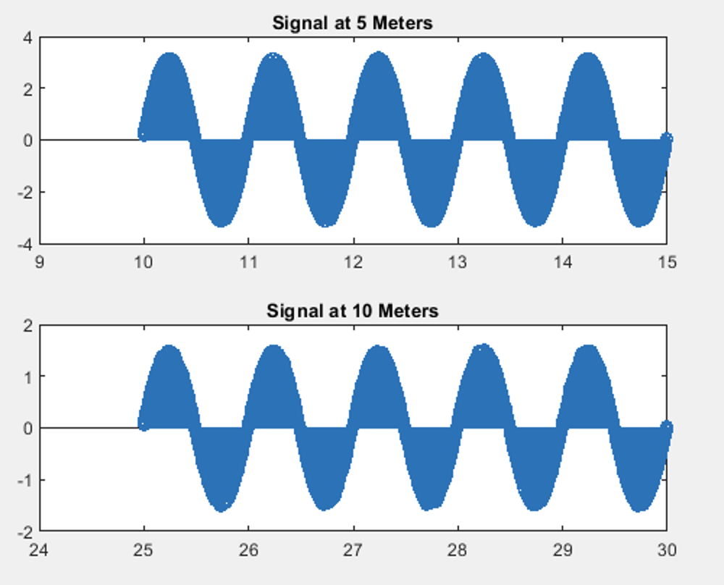

**Figure 3: Filtered (Using moving average filter) and unfiltered versions of the recorded signal in Matlab (LEFT). The sample of signal at 5m and 10m (RIGHT).**

In order to solve for the location of the source, I set the distance equation and power equation equal to each other by using the common variable distance d. In the image below, I begin on the left by solving the system of equations for y, the y coordinate of the source. Then I plug the y coordinate back into the first line to solve for the x coordinate on the right. At the bottom of the page, I solve for the coordinate of the source using actual values I obtained from my simulation (average power of 5m and 10m). The figure on the right shows the calculated values from my algorithm (sourceX and sourceY). They are very close to the coordinates I computed by hand.

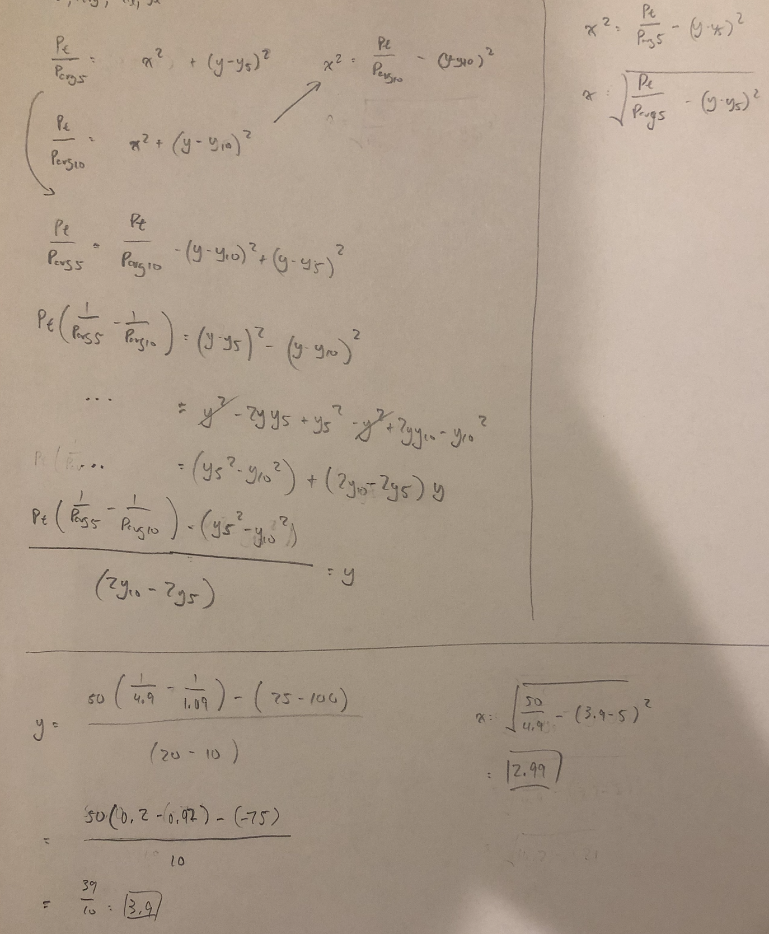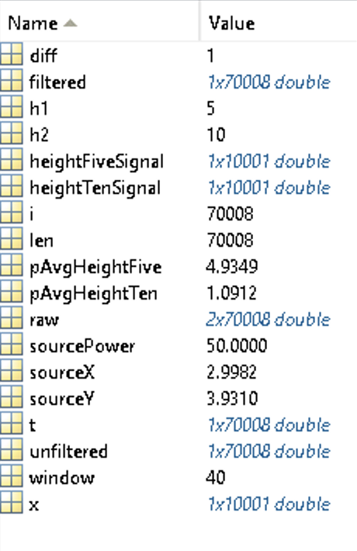

**Conclusion**:

From my simulation, I conclude that the source is at the coordinate of approximately (2.99, 3.93). I think the technique I used works the best because it relies on simple algebra and use of Simulink to clearly depict what is occuring. The filtered I chose was a moving average filter that reduced the noise visibly but not too much to completely skew the amplitude.